Appendix 1.

Fig. S1. Preliminary 150m transect at Henry Buck Trail (41.9428, -73.0158), American Legion State Forest, Barkhamsted, CT. This transect was completed on April 20, 2010. Ant-dispersed species identified in the herbaceous layer during this transect included Spring beauty (*Claytonia virginica*), Trout lily (*Erythronium americanum*), Red trillium (*Trillium erectum*), Duchman’s breeches (*Dicentra cuccularia*), Wood anemone (*Anenome quinquefolia*), Blunt-lobed hepatica (*Anenome americana*), Bloodroot (*Sanguinaria canadensis*), and Sweet white violet (*Viola blanda*). Additional species were found sampling plots and adjacent in 2017, including Downy yellow violet (*Viola pubescens*), Painted trillium (*Trillium undulatum*), Common blue violet (*Viola sororia*), and Canadian wildginger *(Asarum canadense*). This figure shows the species accumulation curve at this location.

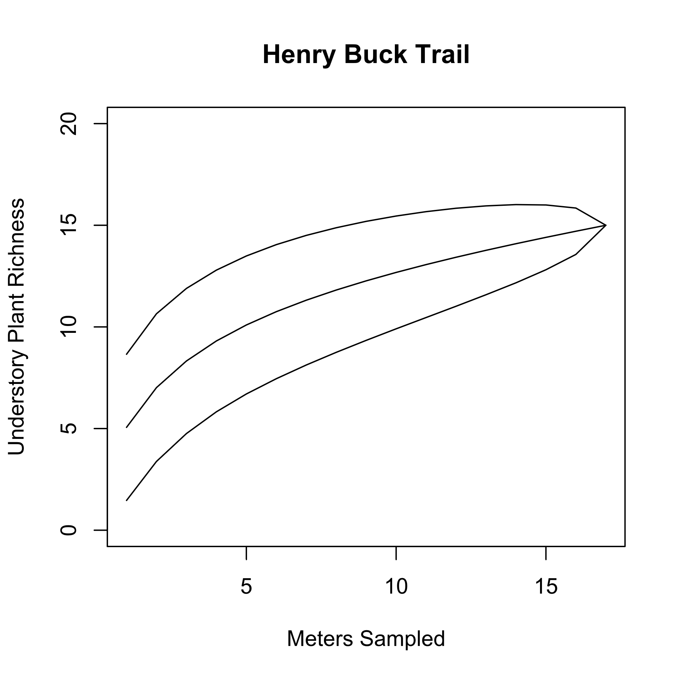

Fig. S2. Galcoe Farm Preserve is located in Wallingford, CT (41.4651 -72.8628) and was sampled in April 2010. This site represents a forest fragment recently recovered from small-scale agricultural production. Several invasive shrubs dominated transects including Burning bush (*Euonymus alatus*) and Asiatic bittersweet (*Eleagnus umbellata).* Ant-dispersed plant species included Bloodroot (*Sanguinaria canadensis*), Trout lily (*Erythronium americanum*), and Red Trillium (*Trillium erectum*). Rue anemone (*Thalictrum thalictroides*) was found at this site, but there is no literature evidence that it presents an elaiosome consumed by ants. This figure shows the species accumulation curve at this location.

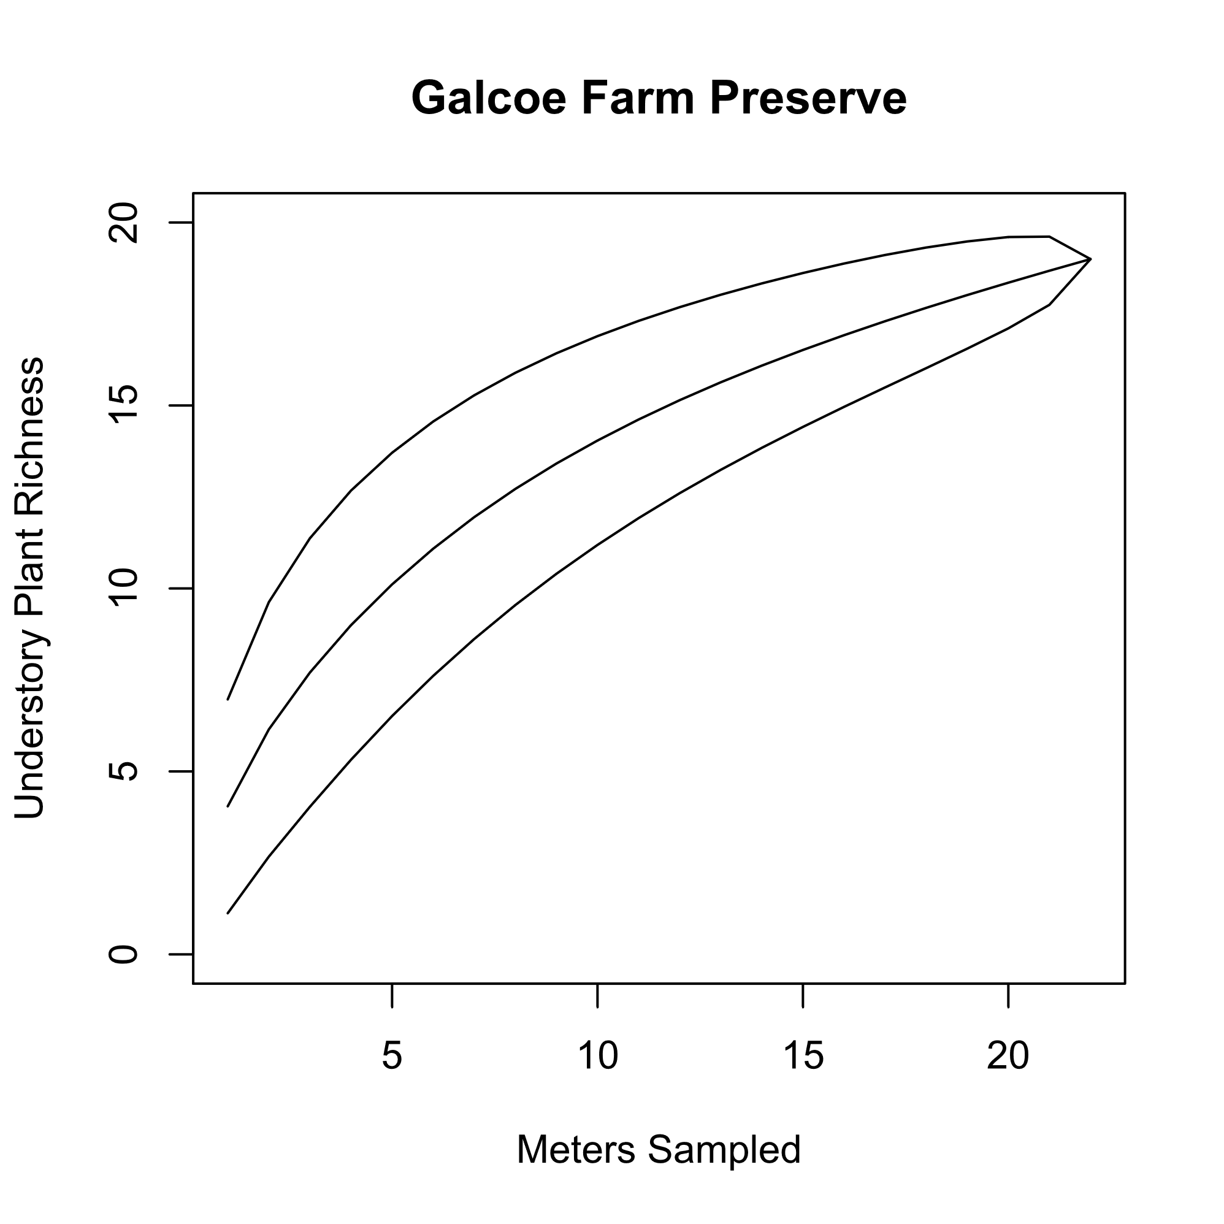

Fig. S3. Ragged Mountain upslope was located in Berlin, CT (41.6314, -72.8078) and was sampled on April 12, 2010 with a 200m transect. This site represents upland forest habitat in Central Connecticut in which many ant-dispersed plants were found in a relatively higher elevation and dry location compared to the other three sites. At this location, the only ant-dispersed plants found were Red Trillium (*Trillium erectum*) and Trout lily (*Erythronium americanum*). This figure shows the species accumulation curve at this location.

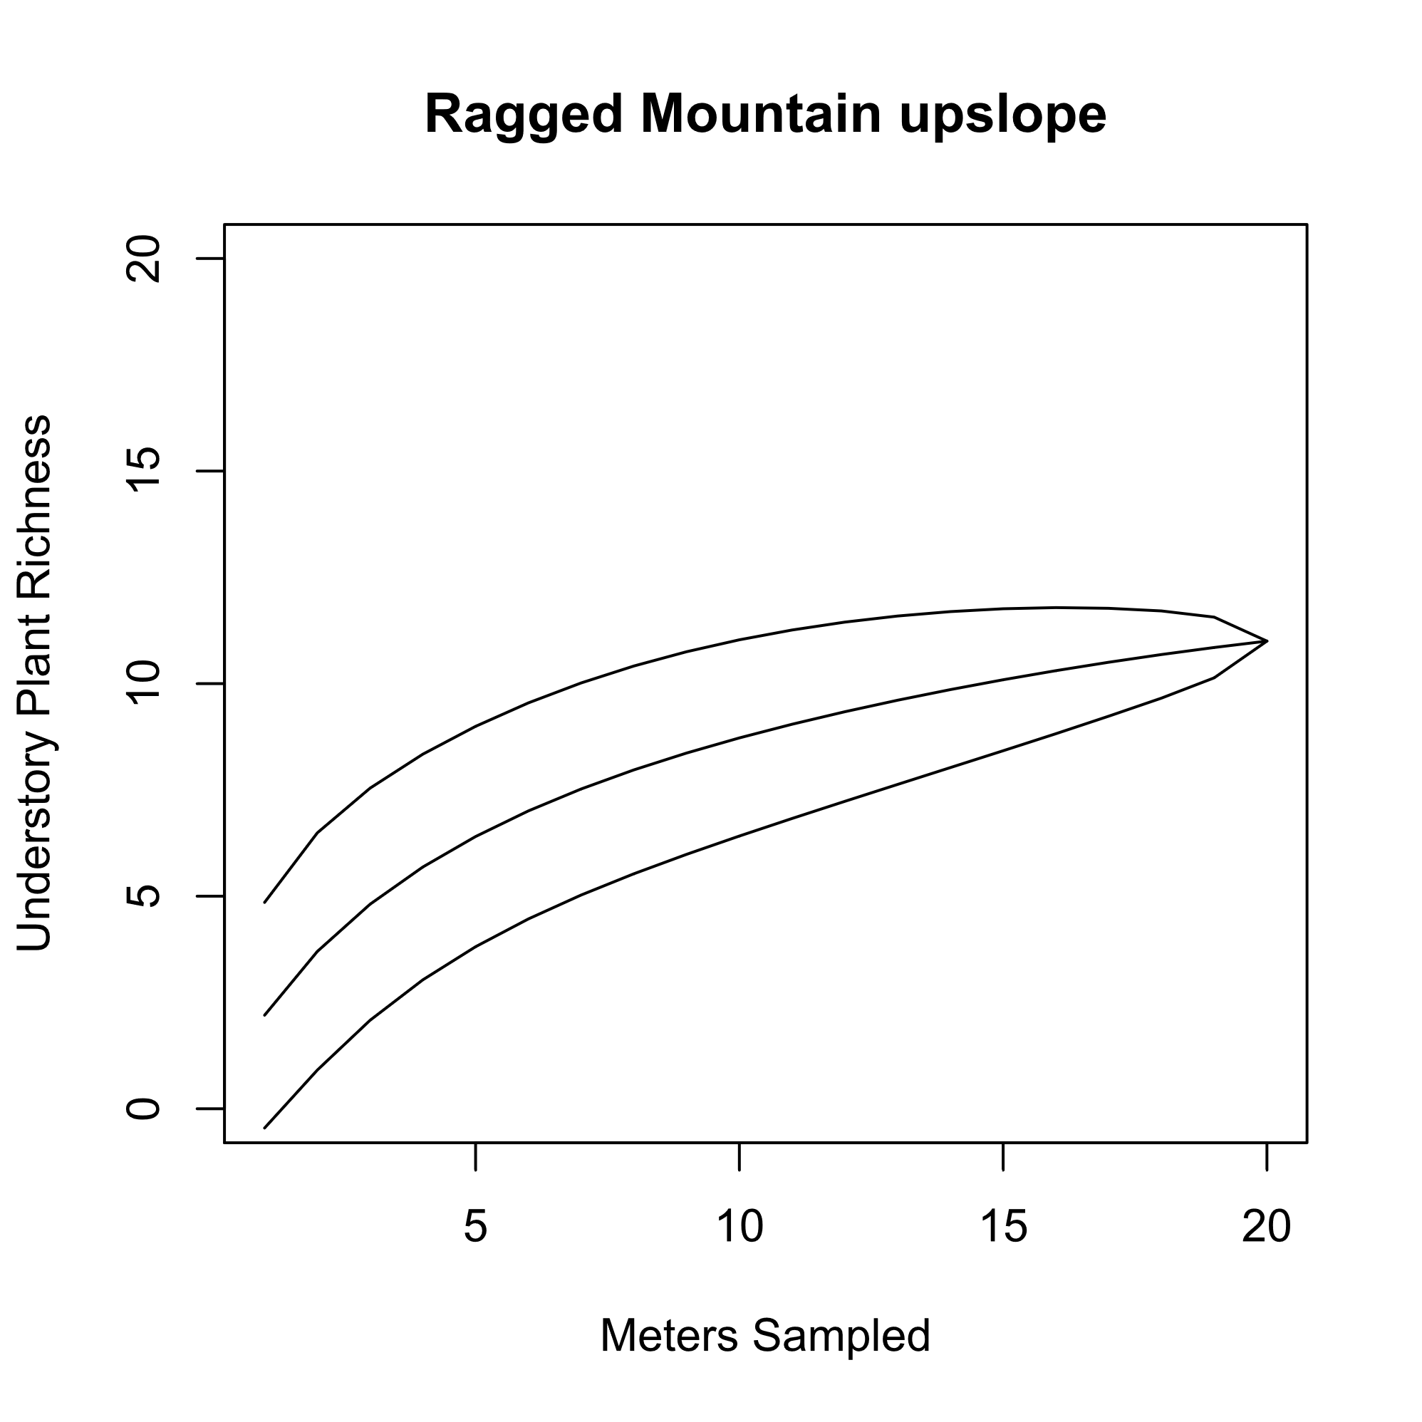

Fig S4. Ragged Mountain downslope (41.6289, -72.8048), while surveyed within the same forest fragment, represents a streamside, mesic forest habitat at relatively lower elevation than the Ragged Mountain upslope site. Ragged Mountain downslope was sampled on April 14, 2010 with a 170m transect. At this location, ant-dispersed plant species include Bloodroot (*Sanguinaria canadensis*)*,* Dutchman’s breeches (*Dicentra cuccularia*), Red Trillium(*Trillium erectum*), and Trout lily (*Erythronium americanum*). One *Viola* spp. was found that appeared to resemble Common blue violet (*Viola sororia*), but a sample was not collected to verify species identification. This figure shows the species accumulation curve at this location.

